WEALD HARNESS CLUB
World Cup Style Event Saturday 11th May 2019

Mobile on The Day 07885 672444

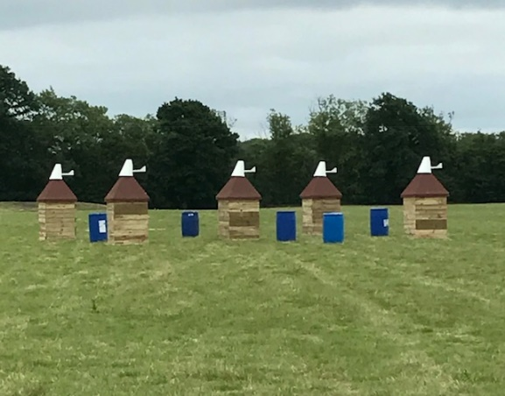

Directions:
From M20 Junction 4: take A228 towards Paddock Wood via Mereworth and by-passing East Peckham. At the roundabout by the Hop Farm, go straight across and at next round about (approx. 2 miles) turn left into Badsell Road. At the traffic lights turn right and immediately left into Mascalls Court Road. Turn left at the end into Mile Oak Road and right opposite the Elm Tree pub into Pearsons Green Lane. Follow the road pass Willow Lane (on the left) and take next left into Old Hay which is a concrete road. This is narrow with passing places. At the end of the concrete road past Scrapco and the Kent Shooting Club there are gates for New Hay Farm. Go through them onto the unmade road for a further 800 m or so. Venue and parking at the end of the track on the right near the barn.

From A21 at Kippings Cross, turn on B2016 towards Paddock Wood passing through Matfield. At the traffic lights by Mascalls School turn right into Mascalls Court Road. Then follow directions above (in italics).

Come and have a fun day driving round our fields over flat ground, through obstacles and cones. Course open for walking at 9.30 am. Each turnout will have the opportunity in the morning of driving the obstacles once after 10.30 am as a warm up. This is followed by ploughman’s lunch (2 tickets inc with each entry, more available on payment of £5.00 each). Tea, coffee & squash available during the day. After lunch, each competitor can drive the obstacles and cones twice which will all be in one field. A longer drive around a separate field is available before tackling the course. Classes to be split according to entries.

Marathon dress and marathon width carriages are order of the day. Hard hats & body protectors to be worn.

Entry fee £30.00 per turnout. Late entries if space allows. Non WHC members £35.00.

Entries close: Monday 6th May 2019. For times ring Jane Lamb for times Thursday 7 - 9 pm on 07885 672444. I will endeavour to Facebook them on Weald Harness Club page or email where possible

RULES AND CONDITIONS OF ENTRY
1. The decision of the Judges is final
2. The organisers reserve the right to alter or cancel the competition in the event of unforeseen circumstances.
3. Entry fees will not be refunded except on production of a Veterinary Surgeon's or Doctor's certificate.
4. Objections must be made in writing to the Event Secretary, within 15 minutes of the class having been judged, accompanied by a deposit of £10, which shall be returnable should the objection be sustained.
5. Horses/ponies must be 4 years of age or older.
6. Junior Whips 14 years and under must be accompanied by a competent adult when driving.
7. Hard hats and body protectors are compulsory for whips and grooms and also whilst riding or driving on site.
8. All competitors must be covered by adequate Third-Party Insurance and must sign the declaration to this effect on the Entry Form.
9. Neither the organising committee of the Weald Harness Club, nor any other landowner, nor any agent, employee or representative of these bodies, save for the death or personal injury caused by negligence of the organizers or any one for in law they are responsible, accepts, any liability, for any accident, loss, damage, injury or illness, to horses, owners, driver, grooms, spectators, land or any other person or property whatsoever, whether caused by their negligence, breach of contract, or in any way whatsoever.
10. The organisers of this event have taken reasonable precautions to ensure the health and safety of everyone present. For these measures to be effective everyone must themselves also take all reasonable precautions to avoid and prevent accidents and must obey the instructions of the organisers and all officials and stewards. You will be asked to sign a statement to this effect.
11. Please respect all Out of Bounds areas and park as directed. The venue is adjacent to an active private airfield.

DOGS ON LEADS PLEASE Please take domestic rubbish away with you.
A Club First Aid officer will be on site. Should the need arise for veterinarian or medical assistance, the local service providers will be called. The nearest hospital is at Pembury with A&E, local vet is Putlands at Paddock Wood or Bell Equine at Mereworth.
----------------------------------------------------------------

ENTRY FORM: Saturday 11th May 2019 World Cup Style Event

Name & Address: ………….……………………………………………………………….

………………………………………………………………………………………………….

Telephone………………………… EMAIL:…………………………..

Turnout Type: Pony / Horse Single / Pair/ Tandem / Team

Name(s) of Horse(s) or Pony(s) ……………………… Height………..

Insurance Details ………………………………………………

Are you Assessed and by which Club?......................................

Cost: Entry £30.00 Member £35.00 Non Member Extra lunch tickets @£5 each

Total amount paid. £………………………
Cheques made out to ‘Weald Harness Club’ and sent to:
Jane Lamb
Nettlestead Lodge
Maidstone Road
PADDOCK WOOD
Kent TN12 6DA
07885 672444
jane@nettlesteadcarriage.co.uk

I agree to abide by the rules and conditions on the schedule for this event:

………………………………………….. (Signature) ………………………………… (Name in capitals)
Date: .. / .. / 2019

