WEALD HARNESS CLUB
World Cup Style Event Saturday 14th May 2022

Mobile on The Day 07885 672444

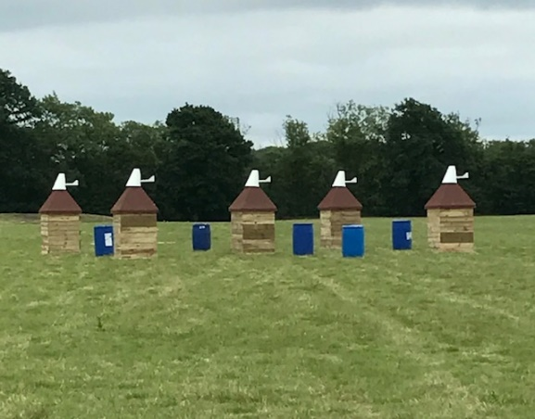

Come and have a fun day driving round our fields over flat ground, through obstacles and cones. Course open for walking at 9.30 am. Each turnout will have the opportunity in the morning of driving the obstacles once after 10.30 am as a warm-up. Tea, coffee & squash available during the day. After lunch, each competitor can drive the obstacles and cones twice which will all be in one field. A longer drive around a separate field is available before tackling the course. Classes to be split according to entries.

Marathon dress and marathon width carriages are order of the day. Hard hats & body protectors to be worn.

Entry fee £35.00 per turnout for WHC members (£45.00 non-members). Late entries if space allows.

Entries close: Tuesday 10th May 2022. For times ring Jane Lamb for times Thursday 7 - 9 pm on 07885 672444. I will endeavour to Facebook them on Weald Harness Club page or email where possible.

RULES AND CONDITIONS OF ENTRY
1. The decision of the Judges is final
2. The organisers reserve the right to alter or cancel the competition in the event of unforeseen circumstances.
3. Entry fees will not be refunded except on production of a Veterinary Surgeon's or Doctor's certificate.
4. Objections must be made in writing to the Event Secretary, within 15 minutes of the class having been judged, accompanied by a deposit of £10, which shall be returnable should the objection be sustained.
5. Horses/ponies must be 4 years of age or older.
6. Junior Whips 14 years and under must be accompanied by a competent named adult when driving.
7. Hard hats and body protectors are compulsory for whips and grooms and whilst riding or driving on site.
8. All competitors must be covered by adequate Third-Party Insurance and must sign the declaration to this effect on the Entry Form.
9. Neither the organising committee of the Weald Harness Club, nor any other landowner, nor any agent, employee or representative of these bodies, save for the death or personal injury caused by negligence of the organizers or any one for in law they are responsible, accepts, any liability, for any accident, loss, damage, injury or illness, to horses, owners, driver, grooms, spectators, land or any other person or property whatsoever, whether caused by their negligence, breach of contract, or in any way whatsoever.
10. The organisers of this event have taken reasonable precautions to ensure the health and safety of everyone present. For these measures to be effective everyone must themselves also take all reasonable precautions to avoid and prevent accidents and must obey the instructions of the organisers and all officials and stewards. You will be asked to sign a statement to this effect.
11. Please respect all Out of Bounds areas and park as directed. The venue is adjacent to an active private airfield.

DOGS ON LEADS PLEASE Please take domestic rubbish away with you.
A Club First Aid officer will be on site. Should the need arise for veterinarian or medical assistance, the local service providers will be called. The nearest hospital is at Pembury with A&E, local vet is Putlands at Paddock Wood or Bell Equine at Mereworth.
----------------------------------------------------------------
Data Protection Statement
Weald Harness Club is affiliated with British Carriagedriving. The organisers of events run under BC rules all retain data provided by those entering such competitions. By completing the entry form and entering the competition, the competitor understands and agrees that:
- This data is used for organising and running of the event and planning of future events
- The publication of results of the competitions and competitors on paper and electronic media
- The publication in any event catalogue of the county of residence of the competitor
- The use of the data for analysis purposes to include but not limited to location of competitors, travelling distances to events, number of competitors attended in current and previous years, performance of competitors at events

Directions:
From M20 Junction 4: take A228 towards Paddock Wood via Mereworth and by-passing East Peckham. At the roundabout by the Hop Farm, go straight across and at next round about (approx. 2 miles) turn left into Badsell Road. At the traffic lights turn right and immediately left into Mascalls Court Road. Turn left at the end into Mile Oak Road and right into Pearsons Green Road. Follow the road past Willow Lane (on the left) and take next left into Old Hay which is a concrete road. This is narrow with passing places. At the end of the concrete road past Scrapco and the Kent Shooting Club there is an electric gate for New Hay Farm. Go through this (push green button on right) onto the unmade road for a further 800 m or so. Venue and parking at the end of the track on the right near the barn.

From A21 at Kippings Cross, turn on B2016 towards Paddock Wood passing through Matfield. At the traffic lights by Mascalls School turn right into Mascalls Court Road. Then follow directions above (in italics).

What3Words: repaid.storybook.chuckle

COVID 19
If anyone in your household is showing any symptoms, high temperature, new cough, or loss of sense of taste/smell or, has been in contact with anyone COVID positive in the last 14 days, DO NOT come to the event but stay at home. Anyone travelling on a carriage must be from the same household/bubble. The Committee will not be able to find you a groom!

On arrival, you will be required to provide a list of all those in your party who are in attendance: name, mobile number, email address. Limit your party to the absolute minimum: i.e., driver, groom, one other (may require more for multiples), driver of vehicles only. In accordance with government regulations, spectators are NOT allowed. The names on your list will be checked against those provided on your entry form.

When course walking, please adhere to 2m social distancing guidelines and DO NOT TOUCH THE CONES or OBSTACLES. In the lorry park, please keep a distance of 5m between lorries & trailers of separate camps.

WHC Committee will do its utmost to keep everyone safe, but event attendees must also assist. Acceptance of all COVID precautions is a condition of entry and any breaches will be taken seriously and dependant on severity may result in those involved being sent home without any refund.

Please bring a supply of sanitizer, disposable protective gloves, and appropriate wipes with you and wear a face covering at your own discretion. Whenever possible please use your own toilet facilities, but if you need to use those on site, do sanitise your hands before and afterwards.

ENTRY FORM: Saturday 14th May 2022 World Cup Style Event

Name & Address: ………….……………………………………… (D.O.B of Junior ../../…)

………………………………………………………………………………………………….

Telephone………………………… EMAIL:…………………………..

Turnout Type: Pony / Horse Single / Pair/ Tandem / Team

Name(s) of Horse(s) or Pony(s) ……………………… Height………..

Insurance Details ………………………………………………

Are you Assessed and by which Club? Yes/No by ......................................

Names of all in your party & contact numbers/email address for COVID19 track & trace:
- …………………………………………………………………………………….
- …………………………………………………………………………………….
- …………………………………………………………………………………….

Grooms of Junior competitors must be over 18 years of age.

Cost |  | Total
Entry | WHC Member @ £35.00 (£45.00 non-member | £
NB Non – members | WHC Membership @ £30 p/a (or £20 with BC full/associate membership) | £
NB Non – members | WHC Junior Membership (under 18) £20 (£15 with BC full/associate membership) | £
 | TOTAL PAID | £

I wish to join WHC and receive benefit of reduced entry, application form attached Yes / No
(Membership forms can be found on www.wealdharnessclub.co.uk or the WHC Facebook Page)
TOTAL £ _______________

Cheques made out to ‘Weald Harness Club’ or Bank Transfer (30-92-36 00553526). Entries to:
Jane Lamb, Nettlestead Lodge, Maidstone Road, Paddock Wood, Kent TN12 6DA 07885 672444 jane@nettlesteadcarriage.co.uk by Tuesday 10th May 2022.
- I agree to abide by the rules and conditions on the schedule for this event.
- I confirm my horse(s) vaccination(s) comply with BC Rule Book, Annex 3,1.3
- I confirm that I and my groom(s) are free from COVID19 at this time and have not been in contact with anyone COVID positive in the last 14 days.
- I confirm that my carriage(s) comply with the requirements of Article 937 and understand that my marathon carriage may be the subject of random weight checks to ensure compliance with article 937.4. (This rule may be waived if stated in the event schedule).

Signed ………………………………………….. (Signature) ………………………………… (Name in capitals)
Date…../…../2022

