|  |  |  |  |
| --- | --- | --- | --- |
|  | |  |  |
|  | | **WEALD HARNESS CLUB**  President: Mr Barrie Luck  Club founded in 1977.  **July 2022 Newsletter** | | |

July is upon us; the Summer is flying by, and the outdoor season is in full swing!

Our AGM in March had a low attendance so possibly next year we will make this a pub social/dinner rather than booking a hall?

We would like to congratulate Barrie Luck on receiving his Outstanding Achievement Award from British Carriage Driving. Very much deserved! The write up was quite impressive thanking Barrie for his selfless support to carriage driving for over 60 years!!!

Congratulations to Jane on passing all the requirements to fulfil the role as judge, not just for dressage but cones and obstacles too. She has spent many hours shadowing judges and attending various courses. We look forward to seeing her sitting at C very soon.

In May we had a visit to Rhoden Rehabilitation Centre. We were shown the water treadmill in action and the benefits of working the horses in water.

A visit to the Carriage Museum in Maidstone had to be cancelled due to lack of interest. We appreciate not everyone can make a weekday outing but unfortunately this was our only option.

The Club sponsored an obstacle at Sandringham this year. It was great to see the banners flying for us.

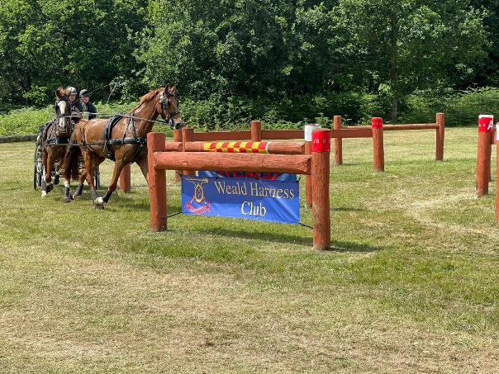

We have had ‘Have a go days’ at Old Hay which have been well supported by members. This has attracted new members to the club too. The days aim to give a relaxed taste of a competition format without the pressure.

Our next event is going to run at Old Hay with Bradbourne Carriage Driving Club. This will be an ODE with Gateway classes. If you’re not able to compete perhaps you’d like to come along and help.

The schedule can be found on our website page.

The drive down to Old Hay has now been resurfaced and looks great.

Future events:

13th august at Old Hay

29th August At Bethersden

(Schedules on the website)

We hope you are all managing to get out with your horses and are enjoying the events the club is putting on. As always if anyone has any feedback/suggestion please do not hesitate to get in touch.